
Mentor Training – Session 4

Name

Date

Session 4 Workbook
Mentor Training Session 4
Icebreaker
“It’s also pretty clear that a teacher makes extensive use of procedures stored in the long-term memory.”​

​Willingham (2009), p.191

What does this quote mean?

How does this resonate with you?

Do you agree?

What implications does it have for a mentor?

Part 1 – ECPDP revisting Year 1
Year 1 Blocks
Block 1​  “Teach, don’t tell behaviour…”  Tom Bennett, 2021 | Block 2​  “You should interleave concepts within a topic, especially ones that students tend to get confused between.”​  Busch, 2022
Block 3​  “It is not helpful to say that a pupil ‘is SEND’ or ‘there are SEND pupils in our class’, and this language may undermine efforts to establish and maintain high expectations for the learning of all pupils. It is more helpful to say pupils ‘have SEND’ or ‘there are pupils with SEND’ within a class. SEND is not a fixed or permanent characteristic.​”  EEF, 2021 | Block 4​  “Knowing students’ likely misconceptions has no benefit unless lessons and delivery are structured to address them.”​  Great Teaching Toolkit, 2020
Block 5​  “Feedback interventions are double edge swords because feedback interventions do not always increase performance and under certain conditions are detrimental to performance.”​  Kluger & DeNisi, 1996 | Block 6​  Parental engagement has a positive impact on average of 4 months’ additional progress. It is crucial to consider how to engage with all parents to avoid widening attainment gaps.​  EEF, 2021

Space for notes:

Part 2a – Deepening the evidence base
DfE Evaluation of ECF
Use this space to record down any thoughts or reflections.
What resonates from the data with your mentoring experience?​ | What implications does this have for you and your ECT during Year 2?
What does not fit with your experience so far? | What might you try differently in your mentoring role?
Different lenses for ECF
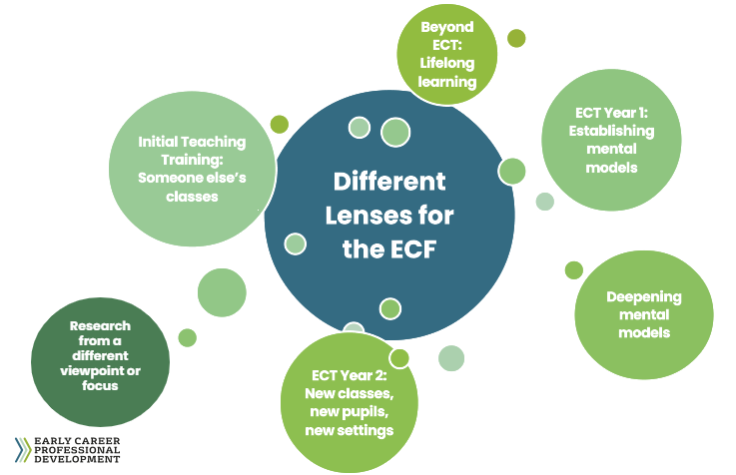

Space for notes:

Part 2b – Deepening Blocks 7 and 8
Reduce cognitive load
What are the nine ways suggested? | What have you heard of before? Are there any new ways?
How can this support your work with your ECT? What might you share? | How does this support you in thinking about how you present feedback or guidance to ECTs?
Source Reference: @TeacherToolkit (2022). 9 Ways to Reduce Cognitive Load. [online] TeacherToolkit. Available at: https://www.teachertoolkit.co.uk/2022/05/01/reduce-cognitive-load/

Part 3 – ECT action steps
Next steps for your ECT
The Year 2 Blocks

Block 7: Embedding a positive climate for learning​
Block 8: How pupils learn: making it stick​
Block 9: Enhancing classroom practice: grouping & tailoring​
Block 10: Revisiting the importance of subject & curriculum knowledge​
Block 11: Deepening assessment, feedback & questioning​
Block 12: Continuing your professional development​

Space for notes:

Next steps for your ECT

Block​ | ECT Strength(s)​ | ECT Area of focus​ | Priority for Development​
Block 7: Embedding a positive climate for learning​. | ​ | ​ | ​
Block 8: How pupils learn: making it stick​. | ​ | ​ | ​
Block 9: Enhancing classroom practice: grouping & tailoring.​ | ​ | ​ | ​
Block 10: Revisiting the importance of subject & curriculum knowledge.​ | ​ | ​ | ​
Block 11: Deepening assessment, feedback & questioning​. | ​ | ​ | ​
Block 12: Continuing your professional development.​ | ​ | ​ | ​

Structuring feedback
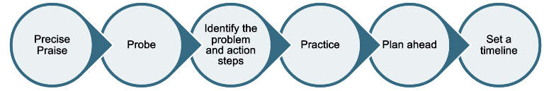

Precise Praise​  What areas of the ECPDP, with specific examples, could you praise?​ | Probe​  What questions will you ask around specific areas of the ECPDP?​  ​ | Identify the problem and action steps​  What examples of action steps could support the ECT? What practical ideas can you share? Who else could be ‘observed’ to support your ECT?​  ​
Practice​  What evidence or good practice could be shared? What specific ECF evidence can you refer to here?​  ​ | Plan ahead​  How might the ECT implement this? How and when? What other support might be needed?​  ​ | Set a timeline​

Space for additional notes:
Further Reading

Bambrick-Santoyo, P. (2012) Leverage leadership: A practical guide to building exceptional schools. San Francisco: Jossey-Bass. ​

Bennett, T. (2021). The running the room companion: issues in classroom management and strategies to deal with them. Melton, Woodbridge: John Catt Educational Ltd.​​

Busch, B. (2022). 5 things about Interleaving I’ve changed my mind about | InnerDrive. [online] Available at: https://www.innerdrive.co.uk/blog/interleaving-what-we-learnt/.

Coe, R., Rauch, C., Kime, S. and Singleton, D. (2020). Evidence Review Great Teaching Toolkit In partnership with Cambridge Assessment International Education. [online] Available at: https://www.cambridgeinternational.org/Images/584543-great-teaching-toolkit-evidence-review.pdf​.

Department for Education. Evaluation of the national roll-out of the early career framework induction programmes Annual summary (Year 2). (2024). Available at: https://assets.publishing.service.gov.uk/media/65dfa86ff1cab36b60fc475f/DfE_ECF_Report_Year2.pdf. ‌​

Education Endowment Foundation. Special educations needs in mainstream Schools – guidance report. (2021). Available at: https://d2tic4wvo1iusb.cloudfront.net/production/eef-guidance-reports/send/EEF_Special_Educational_Needs_in_Mainstream_Schools_Guidance_Report.pdf?v=1713774890. ​

‌Kluger, A.N. and DeNisi, A. (1996). The effects of feedback interventions on performance: A historical review, a meta-analysis, and a preliminary feedback intervention theory. Psychological Bulletin, 119(2), pp.254–284. https://doi.org/10.1037/0033-2909.119.2.254. ​

Mayer, R. E., & Moreno, R. (2010). Nine Ways to Reduce Cognitive Load in Multimedia Learning. Educational Psychologist, 38(1), 43–52. https://doi.org/10.1207/S15326985EP3801_6​.

@TeacherToolkit (2022). 9 Ways to Reduce Cognitive Load. [online] TeacherToolkit. Available at: https://www.teachertoolkit.co.uk/2022/05/01/reduce-cognitive-load/.
​
​
​

